Support us…
- Every winter, the FFA sells Fruit, Cheese, and Meat. This is usually a very successful fundraiser.
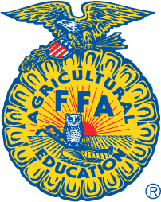
- The FFA Foundation Drive is a collection to support the State FFA Association. In return, the Rushville Chapter is granted many opportunities such as funded trips for FFA members to gain leadership skills and experience in FFA.
- FFA Annual Banquet- The 2015-2016 Rushville-Industry FFA Banquet is set for Saturday, April 16th at 5:30. We ask that you bring a dish to pass, participate in the FFA Alumni Auction (which raises money for the FFA chapter) and enjoy the presentation of this year’s achievements.

If you would like more information regarding any of the events listed above, please contact Grace Foster at gfoster@sid5.com. We appreciate your consideration!

